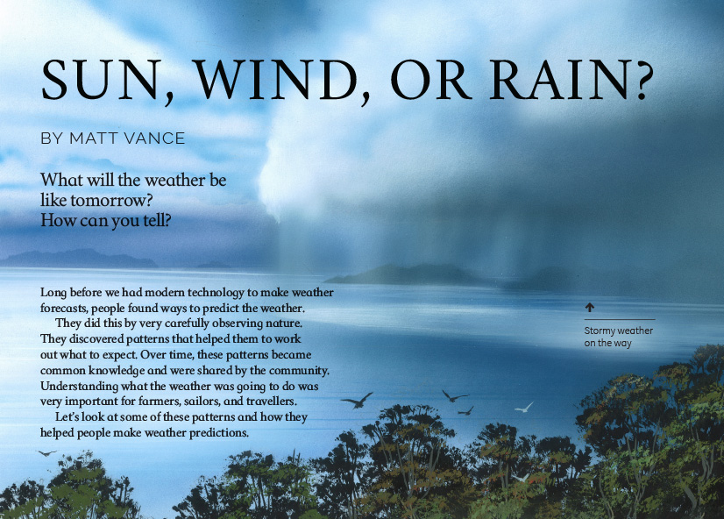
Connected
Level 2
2016

Sun, Wind, or Rain?
by Matt Vance

Overview
This article describes how, over time, people have learned to predict the weather by observing patterns in nature and seeking explanations for them. This article provides scientific explanations for a series of weather patterns that people in Aotearoa New Zealand have observed.
A Google Slides version of this article is available at www.connected.tki.org.nz.

Curriculum contexts

SCIENCE: Nature of Science: Communicating in science  Level 2 – Build their language and develop their understandings of the many ways the natural world can be represented. | Key Nature of Science ideas  Scientists:  - use tentative language when making predictions  - make careful observations, gather and record data, and look for patterns  - share what they learn about the natural world by using diagrams, models, charts, graphs, and written text  - appreciate that science is one way to explain our world and that there may be other ways.
SCIENCE: Planet Earth and Beyond: Earth systems  Level 2 – Explore and describe natural features and resources. | Key science ideas  - Observations of weather patterns allow us to predict the weather.  - Natural features and resources are affected by seasonal change.  - The sun, moon, and bodies of water affect our weather patterns.  - Weather can affect changes in our environment as well as impact on living things.
ENGLISH: Reading  Level 2 – Ideas: Students will show some understanding of ideas within, across, and beyond texts. | Indicators  - Uses their personal experience and world and literacy knowledge to make meaning from texts.  - Makes meaning of increasingly complex texts by identifying main ideas.  - Makes and supports inferences from texts with some independence.

The New Zealand Curriculum

Science capability: interpret representations

Capability overview
Scientists represent their ideas in a variety of ways. They might use models, graphs, charts, diagrams, photographs, and written text. A model is a representation of an idea, an object, a process, or a system. Scientists often use models when something is not directly observable. Models enable scientists to work on their ideas, even though they are often using a limited representation of the “thing” itself. It is important students can identify what is the same and what is different about the model and the thing. | It is important for students to think about how data is presented and ask questions such as:  - What does this representation tell us?  - What is left out?  - How does this representation get the message across?  - Why is it presented in this particular way?  This sort of questioning provides a foundation to critically interact with ideas about science in the media and to participate as critical, informed, and responsible citizens in a society where science plays a significant role.

More about the capability

The capability in action
The science capability “Interpret representations” is about students understanding information that is presented as a description or in visual form and recognising the best way to present information.  Scientific representations include diagrams, models, charts, and graphs, as well as written text.  Scientists develop models and diagrams that best represent their theories and explanations.  Scientists  Scientists use:  - representations that can help both the original scientist and others clarify, critique, and evaluate their ideas, research, and theories  - computer and other kinds of modelling to predict what might happen in certain conditions and then test these predictions to see how accurate the model or idea is  - diagrams or models to communicate science ideas  - graphs to present data  - scientific forms of text involving argumentation that use evidence to debate explanations.  Students  Students should have opportunities to:  - learn to interpret a variety of representations, including models, diagrams, graphs, and text  - develop their own representations of scientific ideas, for example, through modelling using concrete materials or using their own bodies in mime and drama  - recognise how the representation matches the idea and how it is different  - consider and critique a range of representations, including scientific texts, newspaper articles about scientific matters, online information about science matters, and scientific representations developed by their peers. | Teachers  Teachers can:  - help students to be more critical consumers of science information by being explicitly critical themselves and modelling useful questions  - support students to evaluate how information is presented, for example, to assess if a graphical presentation has been done appropriately or is misleading  - ask questions such as:  - What do you think this representation tells us?  - What do the (arrows, lines, symbols, etc.) mean? (that is, helping your students interpret the features)  - Is anything left out? Do you think anything is missing from the representation?  - How does this get the message across?  - Is there anything more you need to know to be able to interpret this representation?  - How does the representation make the science idea clear?  - Which aspects of this representation could mislead the reader?  - Why is it presented in this way?  - Could you suggest a better way to represent it?  - establish a science classroom culture by:  - modelling and encouraging a critical stance  - encouraging students to consider the quality and interpretation of scientific representations  - having learning conversations that involve interpreting, critiquing, and developing representations to demonstrate the idea's relevance in everyday life.

More activities to develop the capability

Meeting the literacy challenges

The literacy demands of the text require students to use, understand, and interpret diagrams and explanations representing weather patterns. Vocabulary demands include technical and meteorological words and phrases. Explanations include reference to historical information including phenomena observed and interpreted by Māori.  The following strategies will support students to understand, respond to, and think critically about the information and ideas in the text. | You may wish to use shared or guided reading, or a mixture of approaches, depending on the reading expertise of your students and the background knowledge they bring to the text.  After reading the text, support students to explore the activities outlined in the following pages.

INSTRUCTIONAL STRATEGIES

Finding the main ideas  Read the title and the opening paragraph. PROMPT the students to make connections to their prior knowledge by having them think, pair, and share their responses to the questions.  Read and DISCUSS page 18. ASK QUESTIONS to draw out the message that scientific knowledge is created by making observations, identifying patterns, and generating explanations. Check that the students understand that a weather forecast is a prediction of what the weather will be like at a certain time and place in the near future. What does “prediction” mean?  - Read the first sentence. What does “weather forecast” mean to you?  - What do you think the phrase, “Over time, these patterns became common knowledge” means? Read the text around these words. What do you think “common knowledge” means? What do you think “over time” means? Look for clues in the text.  - Why is it important for farmers to know what the weather will be like? What about sailors? Or travellers? Can you think of other people who might need to know about the weather? Is it something we need to know? When does your family check the weather forecast?  - The text tells you about how people learnt to predict the weather over time. Ask students to think about how this is similar to how scientists work to understand the world and what did people do that scientists do now?  ASK the students to SCAN the headings and diagrams to understand how the author has structured the article. DISCUSS how this structure helps us to find the different kinds of information. Direct the students to notice that each explanation has a question as a heading, which leads the reader into the answer.  DISCUSS the fact that a feature of scientific explanations is the use of linking words (or “connectives”) that show the relationship between different ideas. Sometimes the connection is made by repeating key words and phrases (for example, “These winds”). Connectives can be used to:  - add ideas together (for example, “and”, “also”)  - show changes in time (for example, “then”, “next”)  - show cause and effect (for example, “because”, “as a result”)  - show contrast (for example, “however”, “unless”). | DISCUSS the fact that an explanation is suggested for why blue cod swallow pebbles during bad weather, but scientists have not gathered enough data to say whether the explanation is true. ASK the students to suggest how scientists might check whether it’s true. Often it is easier to show that an explanation is not true. What findings would show this explanation is not true?  Conduct a jigsaw activity. Have the students work in groups to REVIEW a particular section, IDENTIFY the connectives, and DISCUSS how they help them to follow the explanations. Each group can then EXPLAIN their findings to the rest of the class.  MODEL how to connect the words on page 18 with the illustration on page 19 to explain the weather pattern. Point at the relevant features as you speak.  - The map shows that Canterbury is on the eastern side of the South Island. There are mountains to represent the Southern Alps, which run up the spine of the South Island. The designer has used arrows to show the winds that come from the west, carrying water vapour. They rise up over the Southern Alps. As they rise, the water vapour cools and becomes bigger and bigger droplets of water. The droplets form clouds and eventually they fall as rain. The wind is now carrying very little water vapour so it is warm and dry. These warm, dry winds are called foehn winds. The changing colours represent the changes in temperature, and the arrows show how the winds swoop down over Canterbury. You can see how they create an arch over the blue sky beneath.  Assign each group one of the other weather patterns. Have them DISCUSS it so they fully understand it, then have them explain it to the rest of the class, pointing to the relevant features in the illustration as they do so.  EXPLAIN that you want the students to use a graphic organiser to summarise the information about each of the weather patterns. Model the first one for them.  The pattern The explanation  The nor’ west arch in Canterbury  Whakaari/White Island plume  Waves on the North Island’s west coast  Blue cod stones  Sun halo  Another pattern we have noticed

Meeting the literacy challenges

TEACHER SUPPORT
Observations of weather patterns allow us to predict the weather.  Scientists use diagrams or models to communicate science ideas.  Students  recognise how the representation matches the idea. | 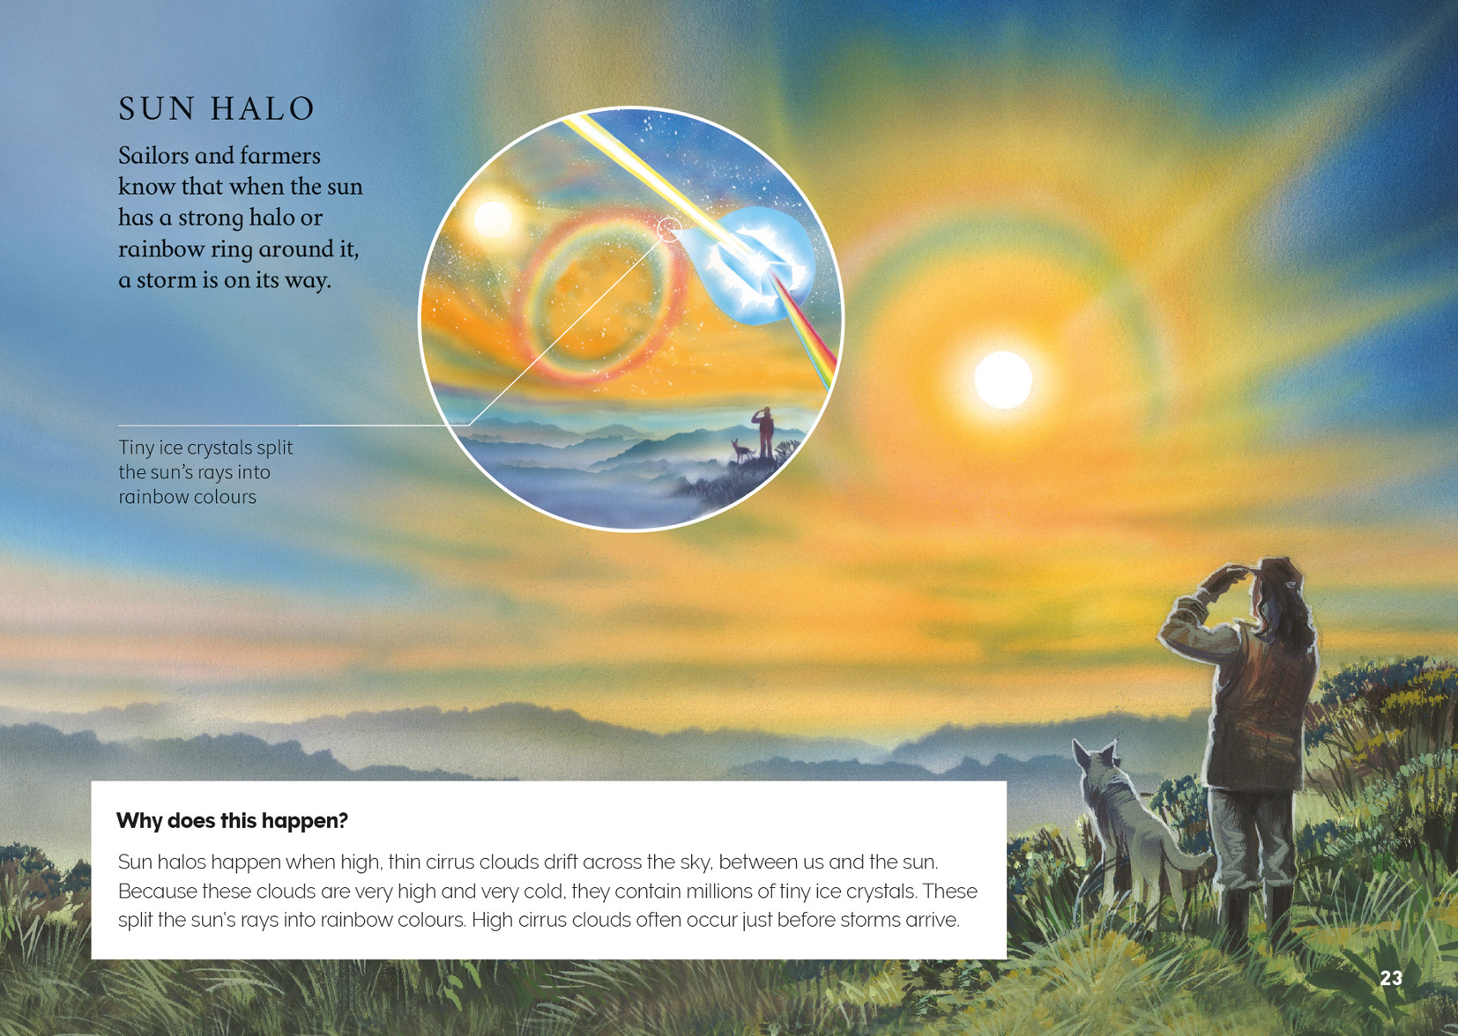

Reading standard: by the end of year 4
The Literacy Learning Progressions
Effective Literacy Practice: years 1–4

Learning activities – Exploring the science
The following activities are a guide for supporting students to explore and develop understandings about the science capability “Interpret representations”. Some activities focus directly on the science capability. Other activities extend student content knowledge across the learning areas. Adapt these activities to support your students’ learning needs.

Activity 1 – Weather patterns where we live
Point out that the article draws on a great deal of traditional Māori knowledge about weather patterns. Discuss why it was so important to Māori to notice these patterns and why people in the past may have been more observant of these patterns.
Display the traditional Māori Weather and Climate Forecasting poster and read “Signs of Change” in Connected 3, 2012. Both the poster and article list some of the signs Māori used to predict changes in the climate or weather. Check that the students understand the difference between “climate” and “weather”. (It is a matter of time: “Weather” refers to changes in climate over minutes, days, or weeks, whereas “climate” refers to patterns of change over weeks, months, years, or even centuries.)
Have the students identify whether any of the examples relate to the local rohe (area). Invite them to share any other weather patterns they know about – either ones they have been taught by their whānau or community or ones they have noticed themselves. (You could encourage them to follow up on this as part of their home learning.) Students may have other kinds of knowledge to share, such as the old adage “Red sky in the morning, shepherd’s warning; red sky at night, shepherds delight”. Record all the patterns that are suggested and keep them on display as the students move into a practical investigation into weather patterns.
Have the students read about the ways meteorologists (weather scientists) collect data about the weather. See, for example, the items in the resources links from Weather Wiz Kids, Exploring Weather, and Ducksters.
Explain that you want the students to set up a weather station, with small groups investigating the weather over a set period (such as a week). You want them to predict what the weather will be, then collect and analyse data to check their predictions. The students could also compare their predictions and data with a published weather forecast.
Data-gathering activities could include:
- Activities from Weather: Making Better Sense of Planet Earth and Beyond
- Observing, using the suggestions in the article on non-instrument weather forecasting
- Making a barometer to measure air pressure, as described in the Science Wonder video
- Creating instruments to measure air pressure, rainfall, wind speed, and wind direction, as described in the Science Kids activities
- Trying one of the weather instruments activities in Weather Wiz Kids
- Conducting some of the experiments described in the teaching notes for “Watching the Weather” Connected 3, 2013.
Have the groups share their findings and compare them with the patterns they shared at the start of this lesson.
- How accurate were your forecasts? How well did the professional forecasters predict the weather?
- Did any of our findings confirm the patterns that local people have noticed? Which ones?
- Do we have enough information to say whether our local knowledge is correct? Do we have any ideas to explain some of these patterns?

Extending the learning
Teach the students to read a weather map and create a glossary of weather terms. Have them identify the non-specific words used in forecasts. For example, “it is very likely”, rather than, “it will ...” This tentative language is a feature of science – after all, we cannot be certain about a future event. Have students use this knowledge and what they have learned about predicting the weather to write a weather forecast for the next day. See the forecast from the Metservice and the explanations from Activity 9 in the resource from the Taranaki Regional Council (see “Resource links” below). Groups of students could present their forecasts to the rest of the class, and at the end of the next day, they could compare their predictions, seeing whose forecast was the most accurate and why this might be.

Activity 2 – Cloudy weather
Clouds are a fascinating subject for many people. But how are they formed? The resource links include a number of explanations of how clouds develop. These include “What Makes the Weather?” in Connected 3, 2012, the explanations in Weather Wiz Kids, and Exploring Weather.
Give the students some sheets of paper and felt pens. Have them read one of the explanations and then create a diagram that explains how clouds are formed and shows their place in the water cycle. Have the students generate a set of criteria for critiquing each other’s diagrams. These might include:
- Is the diagram clearly and accurately labelled?
- Does the diagram show the correct sequence?
- Does it include all the important information?
Have the students select the diagram they think conveys the information most clearly and accurately. Discuss what they have learned about how diagrams communicate scientific information.
- What have you learned from this exercise that you might use the next time you create a diagram?
Have the students conduct outdoor observations of the clouds. They could take photos or sketch them and write written descriptions. Have them research the names of types of clouds in both English and Māori and write an explanation of when and why they are formed.

Extending the learning
When students repeat this exercise in different kinds of weather, they can use their observational records to create their own cloud identification guide.

Learning activities – Exploring the science

RESOURCE LINKS

Building Science Concepts  Book 31 – Water and Weather: The Water Cycle and the Atmosphere  Book 50 – Storms: Extreme Weather  Connected  “Watching the Weather”, Connected 3, 2012 and TSM  Making Better Sense of Planet Earth and Beyond, “Weather” pages 63–90  Science Learning Hub  Observing clouds and weather: http://link.sciencelearn.org.nz/resources/628-observing-clouds-and-weather  Student activity exploring cloud formation: http://link.sciencelearn.org.nz/resources/640-clouds-and-the-weather  Other sources  Traditional Māori weather and climate forecasting poster: www.niwa.co.nz/sites/niwa.co.nz/files/niwa_poster_2006.pdf  Collection of weather sayings www.readwritethink.org/files/resources/lesson_images/lesson775/CollectionSayings.pdf  Weather Wiz Kids  Weather: www.weatherwizkids.com/#  Weather forecasting: www.weatherwizkids.com/?page_id=80  Weather instruments: www.weatherwizkids.com/?page_id=82  Clouds: www.weatherwizkids.com/weather-clouds.htm  Science Kids  Rain gauge: www.sciencekids.co.nz/projects/raingauge.html  Wind speed: www.sciencekids.co.nz/projects/windspeed.html  Wind direction: www.sciencekids.co.nz/projects/windvane.html  Air pressure: www.sciencekids.co.nz/projects/barometer.html  Exploring weather  Exploring weather: www.exploringweather.com/%20  Clouds: www.exploringweather.com/clouds.html  Forecasting: www.exploringweather.com/forecasting.html  Ducksters: Science projects and experiments for kids (weather experiments): www.ducksters.com/science/kids_science_projects.php | Non-instrument weather forecasting:  http://science.wonderhowto.com/how-to/weather-forecast-and-weather-predict-without-technology-0119259/  http://pvs.kcc.hawaii.edu/ike/hookele/weather_forecasting.html (teacher)  Make a barometer to predict weather: http://science.wonderhowto.com/how-to/make-barometer-predict-weather-170451/  Study Jams  Weather instruments (slide show): http://studyjams.scholastic.com/studyjams/jams/science/weather-and-climate/weather-instruments.htm  Clouds and precipitation (slide show): http://studyjams.scholastic.com/studyjams/jams/science/weather-and-climate/clouds-and-precipitation.htm  More on clouds  Droplets: The Kiwi Kid’s Cloud Identification Guide (eBook): www.yumpu.com/en/document/view/10439488/the-kiwi-kids-cloud-identification-guide-science-education-  Cloud identification guide: http://wvscience.org/clouds/Cloud_Key.pdf  TED-Ed: How did clouds get their names? (YouTube animation): www.youtube.com/watch?v=UuW1jhxCgx0  Metservice  How to read weather maps: http://about.metservice.com/our-company/learning-centre/how-to-read-weather-maps/  Weather Study Unit – Taranaki Regional Council  Activity 9: Weather maps: https://trc.govt.nz/assets/Documents/Environment/Education/weather-study-unit.pdf

